SYD366 Money Test Fall 2021

**SYD 366 Money Test**

Please read the case study and answer the questions below. This document, in its .docx format, must be submitted to Blackboard before the due date. Please note that work submitted in any other format will not be graded, and work will not be accepted by email.

Please use Visual Paradigm for your models, and copy PNG or JPG exports or screenshots of your work into this document. The images must be legible. Your professor will not grade any work that isn’t clear and easy to read.

You are welcome to use outside sources in formulating your answers. Be sure to reference your work using APA format.

**Work not properly referenced will be passed to the Academic Integrity Committee for review.**

**You will not share your answers with others, in person or through social/digital media.**

**Any outside help or sharing of answers is cheating and major violations of Seneca College’s Academic Honesty Policy.**

**You agree not to replicate, copy, print or record any questions or answers on this exam to share with others.**

|  |
| --- |
| SENECA’S ACADEMIC HONESTY POLICY |
| As a Seneca student, you must conduct yourself in an honest and trustworthy manner in all aspects of your academic career. A dishonest attempt to obtain an academic advantage is considered an offence and will not be tolerated by the College.  See Seneca Policies on Cheating and Plagiarism:  ( <https://www.senecacollege.ca/about/policies/academic-integrity-policy.html> ) |

**Case Study**

*GetFit Fitness Centres* is a small chain of exercise and training centres throughout Ontario. They operate locations that offer weight training, exercise classes such as Zumba, spinning, and aerobics. They sell monthly and yearly memberships, and also offer a range of branded merchandise, such as t-shirts, water bottles, and other workout gear.

Each location manages its memberships in a spreadsheet; when a new member joins, their information is added to the spreadsheet, which gets updated when the account is renewed every month or year.

The company would like to purchase software to help manage sales of memberships. They would like the software to enable them to easily sign people up in person and online, and enable their members to check their information and renew their account online. Your team has been hired to document GetFit’s requirements and recommend software for them to purchase.

Your team has started looking at the company’s financial structure and found that they allow for different payment methods (payments online are PayPal and credit card and in-person are cash and credit card) and would like to categorize the income and expense transactions accordingly.

*Your team leader has written the following scenarios to capture some of GetFit’s requirements.*

|  |  |  |  |
| --- | --- | --- | --- |
| **Use Case Name** | **Record Membership Sale** | | |
| Triggering Event | Customer wants to join the fitness centre. | | |
| Brief Description | The customer has reviewed the membership options and decided to puchase a yearly membership. The front desk staff completes the sale and payment, and needs to record the income transaction. | | |
| Actors | Front Desk Staff | | |
| Related Use Cases |  | | |
| Preconditions | The Front Desk Staff has opened the Membership Menu. | | |
| Post Conditions | Sale is recorded, membership is set up, and customer can start using the facilities. | | |
| Flow of activities | Actor | | System |
|  | 1 | Requests to record the sale of a new membership | Prompts for customer’s name, email address, phone number, and date of birth, and displays a list of payment methods. |
|  | 2 | Enters in customer’s information and selects a payment method and amount to charge | Determines the date one year from today and adds it as the expiry date, with the rest of the customer’s information, to the membership. Displays the membership, with a prompt for confirmation. |
|  | 3 | Chooses to confirm | Saves the membership. |
| Exception Conditions | The Front Desk Staff chooses to cancel adding the membership. | | |

|  |  |  |  |
| --- | --- | --- | --- |
| **Use Case Name** | **Query Expense transactions** | | |
| Triggering Event | The Manager requires a list of expense data, filtered as required. | | |
| Brief  Description | Allows the Manager to review expense transactions for a specified price range. | | |
| Actors | Manager | | |
| Related Use Cases |  | | |
| Preconditions | The Manager has opened the Reports Menu. | | |
| Post Conditions | Expense transactions displayed. | | |
| Flow of activities | Actor | | System |
|  | 1 | Requests to query expense transactions | Prompts for low amount and high amount. |
|  | 2 | Enters low and high dollar amounts | Retrieves expense transactions that meet the cost range requirements. Displays the list. |
| Exception Conditions | The Manager chooses to cancel querying expense transactions. | | |

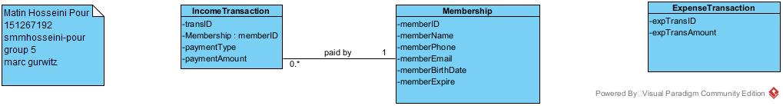

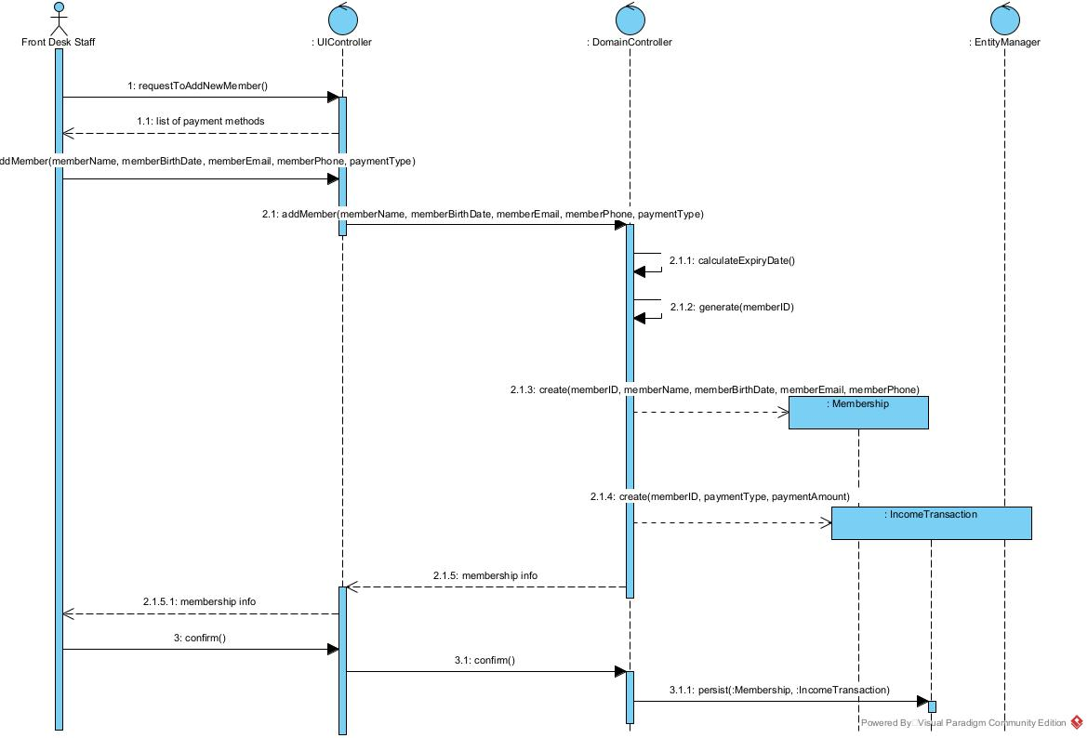

**It persists to the entity manager sorry for the mistake**

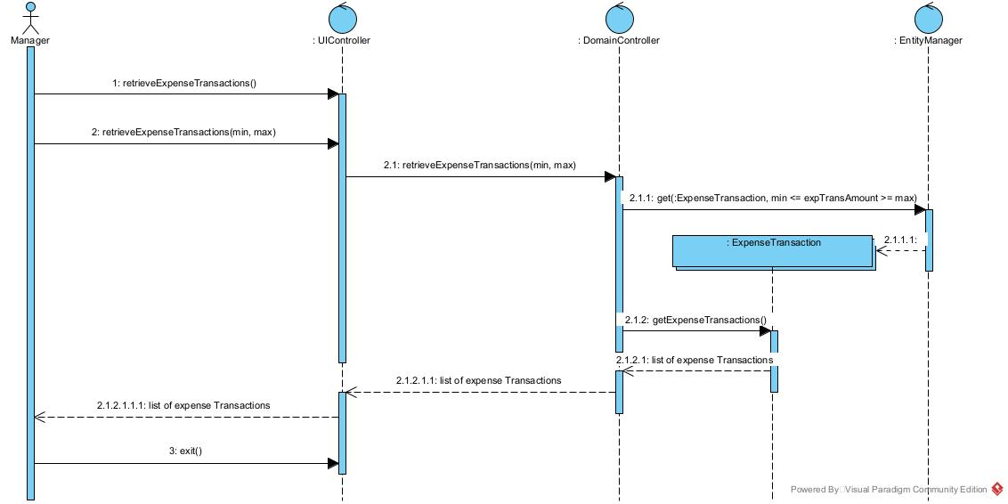

**Question 1** (worth 10 marks)

Complete a **class diagram** to support what your team has learned so far about *GetFit Fitness Centres.*

**Question 2** (worth 20 marks)

Complete two **object level sequence** diagrams, one for each of the above scenarios.

*Answer all of the following questions in clear English.*

**Question 3** (worth 3 marks)

Right now, the membership is tied directly to customer information. The company is considering recording the customer seperately to each membership so that they can provide manage customer information easily and track membership renewals. How would this change your class diagram? How would this change the scenarios and sequence diagrams?

In that case we have to add another class for saving customers information and connect them with a foreign key therefore each membership needs a customerID but not the other way around, because a customer may not want to renew their membership but we need their information in case for promotions or they come back

**Question 4** (worth 3 marks)

What are fixed costs? Explain 4 fixed costs for *GetFit Fitness Centres*.

Fixed costs are the costs that GetFit should pay no matter what

Like their rent, equipments, water, electricity, costs for each membership

**Question 5** (worth 3 marks)

Last month, a customer asked to pay for their membership by personal cheque. Should the Front Desk Staff accept this? What should they do?

They should not change their systems because just one customers wants to be different, they should ask the customer to cash their cheque and then decide to pay by credit card or cash

**Question 6** (worth 3 marks)

What is a budget? What factors does *GetFit Fitness Centres* have to consider when building their business budget?

Budget is their net total money that they decide to spend to build or renovate their business .

They have to consider some stuff may change price over the time of their project. Also they should consider tax for the stuff they have in their business plan to buy and etc.

**Question 7** (worth 3 marks)

To complete the *GetFit Fitness Centres* project we are documenting the business’s requirements for a new system. We’ve looked at Agile and Waterfall (Predictive) Project Management methodologies. You are a team of 2 analysts and a Project Manager. If you were the Project Manager tasked with designing this system, what Project Management Methodology would you use for this project, and why?

I would go with the dynamic, because some parts of the project needs to have deadlines and go step by step and needs some precise budget and timing, but some other parts of the project are less complex than the others so they might be done in a day or two or maybe less, so I would do them as I get time just to lose the headache.